**GENERAL INSTRUCTIONS FOR AUTHORS:**

1. Prepare your contribution in accordance with the following Guidelines:

**Title Title Title Title Title Title Title Title Title Title ( English )**

**Author One**

https://orcid.org/0000-0000-0000-0000

(Required for authors from Brazil) http://lattes.cnpq.br/0000000000000000000000

*Title and name of the institution (Acronym) where the degree was obtained. Function performed and Institution to which it is linked (Acronym), city, state, country. Address for correspondence: Street/Av., number, complement, neighborhood, city, state, country, CEP: 00000-000. Email: autor1@mail.com.*

**Author Two**

https://orcid.org/0000-0000-0000-0000

(Required for authors from Brazil) http://lattes.cnpq.br/0000000000000000000000

*Title and name of the institution (Acronym) where the degree was obtained. Function performed and Institution to which it is linked (Acronym), city, state, country. Address for correspondence: Street/Av., number, complement, neighborhood, city, state, country, CEP: 00000-000. Email: autor2@mail.com.*

**Author Three**

https://orcid.org/0000-0000-0000-0000

(Required for authors from Brazil) http://lattes.cnpq.br/0000000000000000000000

*Title and name of the institution (Acronym) where the degree was obtained. Function performed and Institution to which it is linked (Acronym), city, state, country. Address for correspondence: Street/Av., number, complement, neighborhood, city, state, country, CEP: 00000-000. Email: autor3@mail.com.*

**Abstract( English )**

In this paper we report a synthesis of a reconstruction of the derivative holistic meaning carried out using some theoretical notions of the onto-semiotic approach. We characterize the intended high school curricular meaning about the derivative, based on the mathematical practices proposed in both the core curriculum and in the textbooks. The comparison between the global and curricular meanings allows assessing the “epistemic suitability of curricular meaning”, intended for the high school curriculum. The methodology of the didactical analysis, applied to the case of the derivative in the Mexican curriculum and textbook can be extended to other contents and contexts. The information provided may be useful for high school mathematics teachers because we reveal some biases in the meanings of the derivative privileged by the curriculum that could be avoided to improve the teaching of the derivative.

***Keywords:*** Derivative, Holistic Meaning, Mathematics Curriculum, Teacher Knowledge , Ontosemiotic Approach . **Separated by virgula (,)**

**Título Título Título Título Título Título Título Título (español)**

**Resumen (español)**

En este trabajo presentamos una síntesis de la reconstrucción del significado global de la derivada que hemos realizado con la ayuda de algunas herramientas teóricas del enfoque ontosemiótico del conocimiento y la instrucción matemática. Así mismo, caracterizamos el significado pretendido en el currículo de Bachillerato a partir de las prácticas matemáticas propuestas tanto en el Plan de Estudios como en los libros de texto de dicho nivel. La comparación de ambos significados (global y curricular) permite valorar la idoneidad epistémica del significado curricular. La metodología de análisis didáctico aplicada para el caso de la derivada en el currículo (Plan de Estudios y libros de texto) mexicano, se puede aplicar a otros contenidos y contextos. La información aportada puede ser útil para el profesor de matemáticas de bachillerato ya que revelamos algunos sesgos en los significados de la derivada privilegiados por el currículo que podrían ser evitados para mejorar la enseñanza de la derivada.

***Palabras clave:*** Derivada, Significado Global, Currículo de Matemáticas, Conocimiento del Profesor, Enfoque Ontosemiótico. **Separadas por vírgula (,)**

**Título Título Título Título Título Título Título Título (portugués)**

**Resumo**

Neste trabalho apresentamos uma síntese da reconstrução do significado global da derivada que nós realizamos como ajuda de algumas ferramentas teóricas do enfoque *ontosemiótico* do conhecimento e da instrução matemática. Além disso, fizemos a caracterização do significado pessoal pretendido no currículo do bacharelado partindo das práticas matemáticas propostas tanto no Plano de estudos quanto nos livros de texto desse nível. A comparação dos dois significados (global e curricular) permite valorizar a idoneidade epistémica do significado curricular. A metodologia da análise didática aplicada para o caso da derivada no currículo (Plano de estudos e livros de texto) mexicano, pode ser aplicada a outros conteúdos e contextos. A informação aportada pode ser útil para o professor de matemática de bacharelado porque foram revelados alguns sesgos nos significados da derivada privilegiados pelo currículo que poderiam se evitar para melhorar o ensino da derivada.

***Palavras chave:*** Derivada. Significado Global. Currículo de Matemáticas. Conhecimento do Profesor. Enfoque Ontosemiótico. **Separadas por vírgula (,)**

**Introduction**

The discovery of Calculus1 is one of the great intellectual achievements of civilization, as it has served for more than three centuries as a quantitative tool for the investigation of scientific problems. Calculus is fundamental to areas of mathematics such as probability, topology, group theory, and aspects of algebra, geometry, and number theory. Without it, modern technology and physics might be difficult to imagine ( Kleiner , 2002). However, the teaching of calculus is known to be a source of serious problems, both for students and teachers ( Hitt , 2003), in understanding its fundamental ideas. The derivative is one of the fundamental concepts for the study of calculus, although an excessively algebraic treatment of the concept, without the use of other types of representations for its teaching, can contribute to the emergence of difficulties in its understanding. Artigue (1995) points out that although students can be taught to carry out some derivative calculations more or less mechanically and solve some standard problems, great difficulties are encountered in achieving a satisfactory understanding of the concepts and methods of thinking. that make up the core of this field of mathematics.

Likewise, Artigue (1998) points out that didactic research shows that it is difficult for students to enter the conceptual field of Analysis, when it is not reduced to its algebraized part , but rather aims at the development of modes of thought and techniques that today are based on it. In this way, some students are able to solve exercises with the application of derivation rules, however, they show difficulties when asked to use the derivative, and its various meanings, in non-procedural situations. Some research regarding the meaning of the derivative has focused on describing the characteristics of the meanings constructed by students, showing the existence of conflicts and inconsistencies with respect to the formal meanings presented in textbooks (Ferrini- Mundy and Graham, 1994 ; Sánchez-Matamoros, García and Llinares, 2006). However, various investigations ( Inglada and Font, 2003; Badillo, Font and Azcárate, 2005) show that the origin of students' cognitive conflicts about the meaning of the derivative may be associated with the presentation of the derivative in books. of text; For example, the conflict caused by…

**Guidelines for manuscript formatting**

**Primary Sections** . (Times New Roman , size 12, bold, justified, initial capitalized only)

The text in the body of the article must be in Times New Roman font , size 12, justified, spacing 1.50 lines; indentation 1.25 on first line of paragraphs, letter size sheet; mirror margins; Different even and odd pages, different on the first page, top, bottom and outer margins, 2.5; inner margin, 3.0; no spaces before or after paragraphs. The text must have a minimum of 20 pages and a maximum of 25 pages, annexes are not considered in this number of pages.

|  |  |
| --- | --- |
| **PAGE SETUP** | |
|  |  |

**PARAGRAPH SETUP**

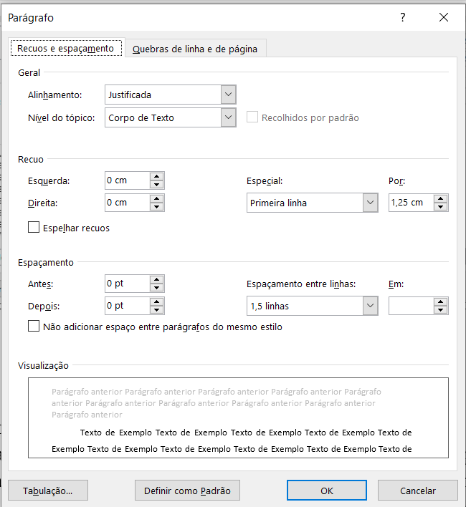

**ORCID iD Registry**

All authors must have ORCID Registration Id, this is a requirement of Paradigma Magazine's indexers (to obtain ORCID code, it is enough to register at <https://orcid.org/register>)

**Metadata**

It is mandatory to provide all the information about the authors in the MANUSCRIPT METADATA on the journal's site when the article is registered, indicating the ORCID links , the curriculum lattes (if applicable) and other useful information about all the authors.

**Highlighting words in the text**

*italic* letters , that is, you should not use bold or underline to highlight text. After each section a line break must be given (ENTER)

**Footnotes**

For footnotes: Times New Roman font , size 10, single line spacing, justified paragraph. It is suggested that footnotes be avoided whenever possible. If they are strictly necessary , they must be listed with Arabic numbers.

**Secondary sections (Times New Roman, size 12, bold, justified)**

The text in these sections of the article must be in Times New Roman font , size 12, justified, spacing 1.50 lines; indentation 1.25 on first line of paragraphs, letter size sheet; no spaces before or after paragraphs

**Citations in the body of the article**

In **indirect citations,** in the body of the article, the names of the authors must be referred to using uppercase (initial) and lowercase letters. If they are in parentheses, they must be digitized in capital letters. For example: Villegas (2021) or (VILLEGAS, 2021).

**Direct quotes** with more than 40 words should be prepared like this : **4 cm** indentation from the left margin , single spacing, without quotes, Times New Roman font , size 10.

**Tertiary sections (Times New Roman, size 12, justified)**

The text in these sections of the article must be in Times New Roman font , size 12, justified, spacing 1.50 lines; indentation 1.25 on first line of paragraphs, letter size sheet; no spaces before or after paragraphs

**Theoretical Reference**

Reference should be given to recent publications (less than five years, current); In the case of sources more than five years old, there must be certainty of the validity of their content or the relevance according to the issue being studied. It is recommended to review previous editions of Paradigma, other specialized and indexed journals, books, master's degree works, doctoral theses and reports (minutes) of events within the scope of the research reported in the manuscript. Authors of articles from Brazil must use the ABNT Standards; Those from other latitudes can use APA Standards.

**Methodology**

**Paradigma is a** multi-perspectivist and pluri-paradigmatic journal , so the articles to be published can be derived from qualitative, quantitative or mixed research. In any case, this section must take into account the following aspects of the strategy used to define, obtain, record, organize, process and produce the information necessary to guarantee the suitability of the study: approach, focus, or perspective; nature of the study according to its intentionality and the type of research question; characterization of research participants; place where it was carried out (of course protecting the real identity, whenever necessary), techniques, instruments, procedures, context, environment and other elements that are necessary for the adequate understanding of the study.

**Figures, Tables, Tables and other graphic elements.**

Figures and tables should be as close as possible to their mention in the body of the text. The title of the **figures** should be sufficiently clear in relation to the image, so that it is not necessary to consult the body of the text. Only the number of the object and the word used to designate it should be in bold. Figure titles should be like this: *Times New Roman font* , size 12, single spaced. The font is *Times New Roman* font , size 10, single spacing. Always mention the source.

**Figure 1** : Title of the figure

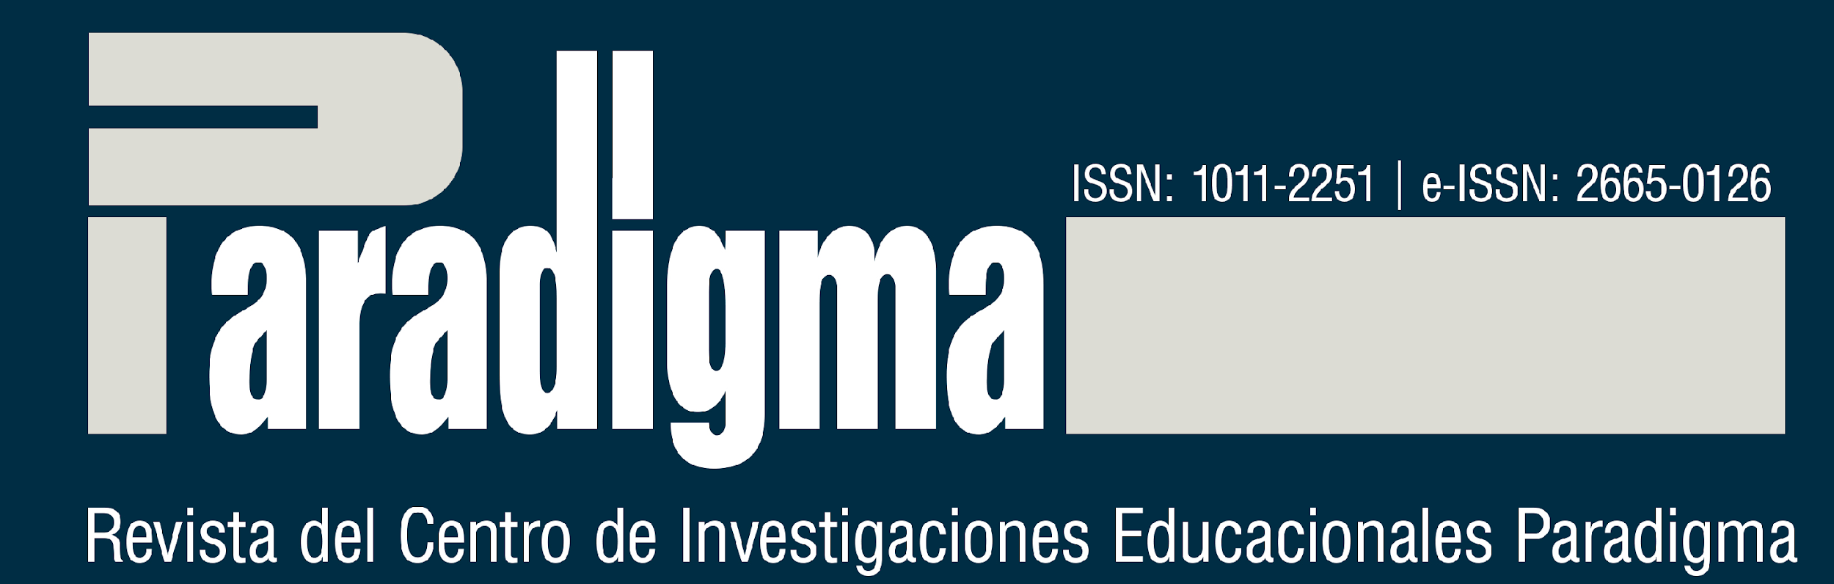

**Source** : Name of the source or last name of the author (year, p. xx )

Use a good resolution, so that the figure is readable for readers at 100% zoom, always respecting the margins of the document.

In relation to **the tables** , the indications are as follows: *Times New Roman font* , size 10, single spacing. **The table titles should read like this :** *Times New Roman* font , size 12, single spacing. Fonts should be in *Times New Roman font* , size 10, single spacing. The source should always be mentioned

Example :

**Table 2:** Student's justifications for the sum of the results when throwing two dice.

|  |  |
| --- | --- |
| **Tasks** | **Student Answers (A)** |
| An even number? | Possible |
| odd number ? | Possible |
| Number 1? | There is a possibility |

**Source** : Author(s) ( year , p. xx ); Elaboration based on Author(s) ( year , p. xx ); Authors ' elaboration _

Tables are ways of presenting quantitative information, made up of numerical data **.** The identification of the tables must be at the top, preceded by the word Table (in bold), followed by its number in order of appearance in the text, in Arabic numerals (in bold), then insert the respective title (without bold). ). The title and content of the tables must be written in *Times New Roman font* , size 12. The title must be separated from the respective numbering by a “:“ The source must always be mentioned. The table must be inserted in the place in the text as close as possible to where it was mentioned in the text. Sources and notes must be digitized in *Times New Roman font* , size 10, single line spacing.

Example 1:

**Table 1:** Height Distribution of 140 of School

|  |  |
| --- | --- |
| **Heights (cm)** | **Number of students** |
| [145, 150] | 2 |
| [150, 155] | 8 |
| [155, 160] | 25 |
| [160, 165] | 40 |
| [165, 170] | 27 |
| [170, 175] | twenty-one |
| [175, 180] | 10 |
| [180, 185] | 7 |
| **Total** | **140** |

**Source** : Author(s) ( year , p. xx ); Elaboration based on Author(s) ( year , p. xx ); Authors ' elaboration _

Example 2:

**Table 1:** Varieties of Qualitative Research indicated in the theses

|  |  |  |
| --- | --- | --- |
| **Item** | **Quantity** | **Percentage** |
| Investigation action | 2 | x% |
| Ethnography | 3 | x% |
| Oral history | 5 | x% |
| Autobiographical Narratives | 12 | x% |
| IAP | 3 | x% |
| Dialogical Research | 0 | x% |
| **Total** | **25** | **x%** |

**Source** : Author(s) ( year , p. xx ); Elaboration based on Author(s) ( year , p. xx ); Authors ' elaboration _

Charts, tables and equations must be in a format that can be edited. Images are not accepted. The use of expressions such as “the Table above” or “the Figure below” should not be used, because at the time of formatting the manuscript their place may be altered.

Every table must have a title indicative of the nature and geographical and temporal scope of the data, numerical, in extenso, without abbreviations, in a clear and concise manner. It must have a number (Arabic, increasing) whenever there are two or more tables in the document.

Regarding the visual appearance of the table, it should not have vertical lines that delimit it to the left and right. It must contain numerical data within the cells, for information quantification of specific observed fact. It must be prepared so that it occupies a single page and represents graphic uniformity (font, body, use of upper and lower case).

**Analysis and Results**

They must be developed from the theoretical and methodological framework, considering the necessary requirements to guarantee originality, scientificity, rigor and precision.

**Conclusions (Ou Considerations Finais/Reflexões Finais)**

Highlight the conclusions and/or positions of the author regarding the results of the study, articulated with the research questions and depending on the problem studied.

**Acknowledgments (when any, not mandatory)**

They must observe the same rules used in the body of the text

.

**References**

Below are examples of references of various types.

Examples :

**Books with 1 author:**

BURKE, P. **What is the history of this achievement?** Translation by Cláudia Freire. São Paulo: Editora da UNESP, 2016.

CAVEING, M. **The problem of objects give the thought mathématique** . Paris: Librairie Philosophique J. Vrin , 2004.

**Books with 2 authors:**

MENDES, IA; STAMATTO, MIS **Normais Schools of Brazil** : spaces for teaching (trans)formation and production of professional knowledge. 1st ed. São Paulo: Ed. Livraria da Physics, 2020.

**Books with 3 authors:**

MENDES, IA; MACHADO, B.F .; SOARES, EC **Playful Arithmetics in the Classroom** . 1st ed. Belém: Sociedade Brasileira de História da Matemática, 2016.

**Books with more than 3 authors:**

MENDES, IA; [Inform all authors]. **Educational sciences, disciplinary fields and professionalization** : knowledge in debate for teacher training. 1st ed. São Paulo: Ed. Livraria da Physics, 2020.

**Books with organizers, coordinators :**

OLIVEIRA, AMP de.; ORTIGÃO, MIR (Org.). **Theoretical and methodological approaches in research in Mathematical Education** . Brasília: SBEM, 2018. (SBEM Collection). Available at: <http://www.sbembrasil.org.br/files/ebook_.pdf>. Access in: 20 Jan. 2020.

CYRINO, MC of CT (Org.). **Emerging themes of research on the training of teachers who teach Mathematics:** perspectives and challenges. Brasília, DF: SBEM, 2018. (Coleção SBEM). Available at: <http://www.sbembrasil.org.br/files/tematicas_emergentes.pdf>. Access em: 20 Jan . 2020.

**Master's degree projects, doctoral theses, course completion projects:**

CAVALCANTE, LGM **Aesthetic Experience with Geometric Forms in Early Years.** 2019. 188 f. Dissertação (Mestrado) - Universidade Federal do Pará, Instituto de Educação Matemática e Cientifica, Programa de Pós-Graduação em Educação em Ciências e Matemáticas, Belém, 2019. Available at: <http://gpsem.online/dissertacoes>. Access in: 20 Jan. 2020.

KHIDIR, KS **Prásticas Socioculturalis Quilombolas para o Teaching of Mathematics: mobilization of knowledge between Community and School.** 2018. 190 f. Tese (Doutorado) – Universidade Federal do Pará, Instituto de Educação Matemática e Cientifica, Programa de Pós-Graduação em Educação em Ciências e Matemáticas, Belém, 2018. Available at: http://gpsem.online/teses . Access in: 20 Jan. 2020.

**Works presented at events:**

ALVARADO PRADA, LEA Methodologias de pesquisa-formação de professores nas dissertações, teses: 1999-2008. In: **IX National Seminário de Pesquisa em Educação da Região Sul** . Anais [do](http://www.ucs.br/etc/conferencias/index.php/anpedsul/9anpedsul/paper/viewFile/3179/482) . Access in: 20 Jan. 2020.

**Magazine/newspaper articles:**

BURGOS, Cinthia del Carmen Humbría ; GONZALEZ, Fredy Enrique. SPACES FOR COMPLEMENTARY TRAINING FOR VENEZUELAN MATHEMATICS EDUCATORS. CASE: VENEZUELAN SCHOOL FOR THE TEACHING OF MATHEMATICS - EVEM. **Hist. Educ .** , Santa Maria , v. 24, e99353, 2020. Available from <http://www.scielo.br/scielo.php?script=sci_arttext&pid=S2236-34592020000100504&lng=en&nrm=iso>. access on 31 Jan. 2021. Epub June 29, 2020. <http://dx.doi.org/10.1590/2236-3459/99353>.

GONZÁLEZ, F. Difficulties in carrying out research work: how to face them. **Educational Praxis** , [S. l.], v. 11, no. 18, p. 275-300, 2014. Available at: https://periodicos2.uesb.br/index.php/praxis/article/view/812. Access em: Jan 31. 2021.

PIRES, LS; MENDES, THE HISTORY OF MATHEMATICS DOES NOT TEACH FUNDAMENTAL NOS MINICOURS BOOKS OF SBHMat (2001-2017). **Teaching Practice Magazine** , v. 5, no. 1 p. 28-44, 2020. Available at: <http://periodicos.cfs.ifmt.edu.br/periodicos/index.php/rpd/article/view/575>. Accessed : May 1, 2020. DOI: <https://doi.org/10.23926/RPD.2526-2149.2020.v5.n1.p28-44.id575>

**Research Projects _**

MENDES, IA **História para o Ensino de Matemática na Formação de Professores e na Educação Básica: uma Análise da Produção Brasileira (1997– 2017)** . CNPq Productivity Research Project. Belém: Universidade Federal do Pará, 2018.

**Legal Documents**

BRAZIL. Law No. 9394/96. **Lei de Diretrizes e Bases da Educação Nacional.** Establishes the directives and bases of national education. Brasília: 1996. Available at: <https://www.planalto.gov.br/ccivil_03/Leis/L9394.htm>. Access in: 25 mai. 2019.

BRAZIL. Ministry of Education. **Opinion CNE/CES No. 1,302, of November 6, 2001** . Defines the National Curricular Guidelines for Mathematics, Bachelor's and Bachelor's Courses. Brasilia: 2002b. Available at: <http://portal.mec.gov.br/cne/arquivos/pdf/CES13022.pdf>. Access in: 25 mai. 2019.

BRAZIL. Ministry of Education. **CNE/CP Resolution no. 1, dated 02/18/2002** . Institui Diretrizes Curriculares Nacionais para la Formação de Professores da Educação Básica, em superior level, undergraduate course, full graduation. Brasília: 2002. Available in: <http://portal.mec.gov.br/cne/arquivos/pdf/rcp01_02.pdf>. Access in: 25 mai. 2019.

BRAZIL. Ministry of Education. **CNE/CP Resolution no. 2, February 19, 2002** . I instituted two undergraduate courses, full graduation courses, and teacher training for Basic Education at a higher level. Brasilia: 2002c. Available at: <http://portal.mec.gov.br/cne/arquivos/pdf/CP022002.pdf>. Access in: 25 mai. 2019.

**Links**

All electronic addresses (links) to INTERNET pages ( URLs ) included in the text must respect the rights of the corresponding authors.